Rule-Based Program and Datasets Relationship Mapping

Yizhen Chen 11/13/22024

Table of Contents

Project Description 3

Objectives 3

Stakeholders 3

Requirements Gathering 4

Rule Development 4

Program and Dataset’s Funding Source matching 5

Data Fields 5

Matching Rule 5

Program and Dataset’s title matching 5

Data Fields 5

Matching Rule 5

Program and Dataset’s PI matching (Yizhen Added) 6

Data Fields 6

Matching Rule 6

Project and Dataset’s Org matching 6

Data Fields 6

Matching Rule 6

Project and Dataset’s description matching 6

Data Fields 7

Matching Rule 7

Grant and Dataset’s PI matching 7

Data Fields 7

Matching Rule 7

Grant and Dataset’s Funding Source matching 7

Data Fields 8

Matching Rule 8

Grant and Dataset’s Org matching 8

Data Fields 8

Matching Rule 8

Grant and Dataset’s Org matching 8

Data Fields 8

Matching Rule 9

# Project Description

Develop a rule-based program to automate the mapping and relationship identification between datasets.

## Objectives

Enable accurate mapping and discovery of relationships between data entities based on predefined rules to support data integration, analysis, and curation.

## Stakeholders

Project Manager: Zack

Tech Leader: Yizhen

Data Curator: Ricardo

# Requirements Gathering

[2.0.0.4](https://nih.sharepoint.com/:f:/r/sites/NCI-CBIIT-FNLCCDI/Shared%20Documents/INS/2-Executing/Data%20Gathering/INS_v3.x/Data_to_Load/2.0.0.4?csf=1&web=1&e=yMnAiK)

We have Program, Project, Publication, Grant and dataset tsv file.

# Rule Development

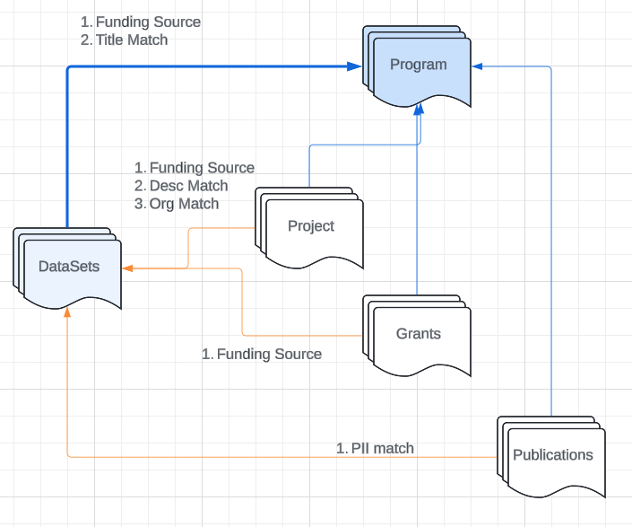

## Program and Dataset’s Funding Source matching

Confident rate: Hight

### Data Fields

Program Fields:

Program.NOFOs

Program.Awards

DataSets Fields:

Description

funding_source

### Matching Rule

If datasets’ fields include any item listed in Program fields (exact match, but case insensitive), then the program and dataset are considered related.

## Program and Dataset’s title matching

Confident rate: Medium

### Data Fields

Program Fields:

program_name

program_acronym

DataSets Fields:

Description

Title

### Matching Rule

If datasets’ fields include any item listed in Program fields (exact match, case insensitive), then the program and dataset are considered related.

## Program and Dataset’s PI matching (Yizhen Added)

Confident rate: Medium

### Data Fields

Program Fields:

Contact_PI

DataSets Fields:

PI_name

### Matching Rule

If datasets’ fields include any item listed in Program fields (exact match, case insensitive), then the program and dataset are considered related.

## Project and Dataset’s Org matching

Confident rate: Medium

### Data Fields

Project Fields:

project_org_name

DataSets Fields:

Description

### Matching Rule

If datasets’ fields include any item listed in Project fields (exact match, case insensitive), then the program and dataset are considered related.

## Project and Dataset’s description matching ML/AI

Confident rate: Medium

### Data Fields

Project Fields:

project_abstract_text

project_title

DataSets Fields:

Description

Title

### Matching Rule

Sematic Matching, Similarity Matching, ML/AI

## Grant and Dataset’s PI matching

Confident rate: Medium

### Data Fields

Grant Fields:

principal_investigators

program officers

DataSets Fields:

PI_name

### Matching Rule

If datasets’ fields include any item listed in Grant fields (exact match, case insensitive), then the program and dataset are considered related.

## Grant and Dataset’s Funding Source matching

Confident rate: Hight

### Data Fields

Grant Fields:

grant_opportunity_number

DataSets Fields:

funding_source

### Matching Rule

If datasets’ fields include any item listed in Grant fields (exact match, case insensitive), then the program and dataset are considered related.

## Grant and Dataset’s Org matching

Confident rate: Medium

### Data Fields

Grant Fields:

grant_org_name

DataSets Fields:

Description

### Matching Rule

If datasets’ fields include any item listed in Grant fields (exact match, case insensitive), then the program and dataset are considered related

## ~~Grant and Dataset’s Org matching~~

~~Confident rate: Medium~~

### ~~Data Fields~~

~~Project Fields:~~

~~grant_org_name~~

~~DataSets Fields:~~

~~Description~~

### ~~Matching Rule~~

~~If datasets’ fields include any item listed in Grant fields (exact match, case insensitive), then the program and dataset are considered related~~